Spoke 7: BIODIVERSITY and SOCIETY
1. Vision
Foster a closer, more systemic and inter-fecund relationship between science and society to understand and protect biodiversity.
2. Mission
Spoke 7 will follow four general principles:
- Establish maximum cross-relationships by examining and communicating biodiversity from a One Health perspective.
- Develop new languages for communication and teaching.
- Strive for tangible and quantitative impact.
- Develop policies based on connecting the world of biodiversity research with policymakers, relevant public and private institutions, and stakeholders.

3. Strategic goals
The primary task of Spoke 7 is to communicate, enhance and share the research themes of NBFC with an international audience and Italian society. To achieve this, we will explore new languages, formats, and methods of communication and education to reach a broader portion of public opinion and new audiences. Tangible, quantitative impact will be an essential element, along with creating effective operational interfaces to connect biodiversity researchers, communicators, policymakers, relevant institutions, and stakeholders. Finally, by enhancing coordination within NBFC, Spoke 7 will create synergies, advertise and increase the socio-cultural impact and visibility of NBFC activities to raise public awareness on biodiversity issues and anthropogenic impacts.

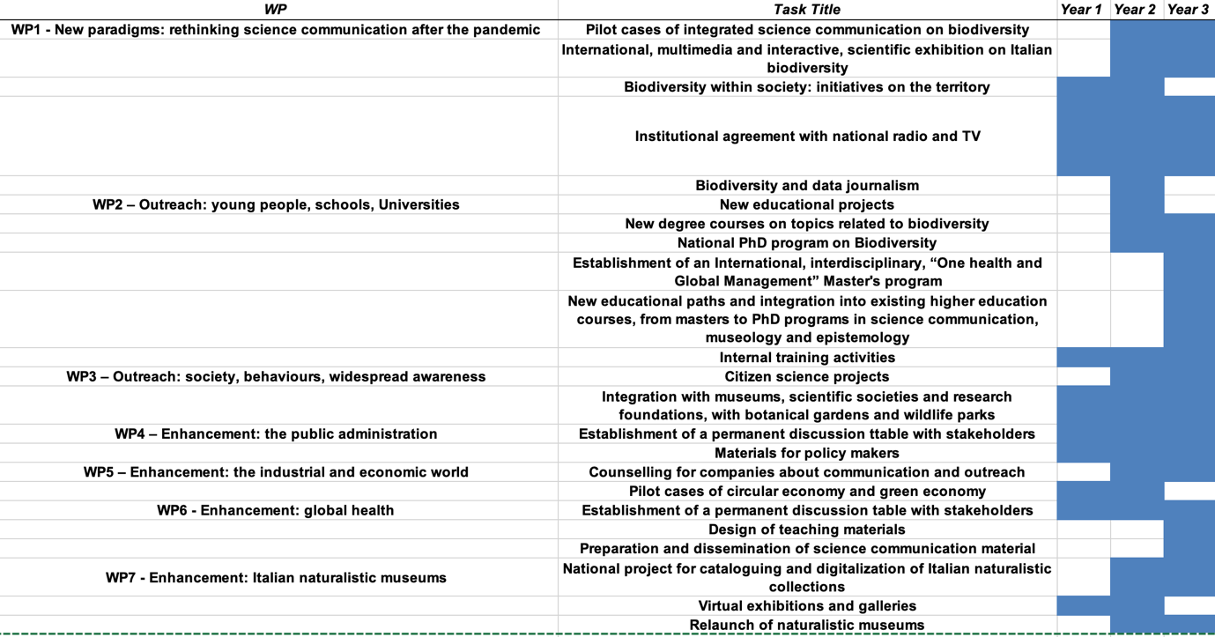

4. The State of Art
The 21st-century biodiversity crisis is a systemic phenomenon that requires integrated solutions and a science-based holistic approach. Its primary drivers include habitat destruction, urbanization, invasive species, pollution, overexploitation of resources, and climate change, all exacerbated by human activities. Addressing this crisis demands paradigm shifts in lifestyles and consumption patterns, regulations grounded in ecological principles, and societal engagement that recognizes biodiversity as vital for ecosystem resilience, economic development, and human survival. Mere conservation of protected areas is insufficient without involving local communities and fostering collaboration. Communication and societal participation are critical to building an effective dialogue between science and the public. An evolutionary perspective is essential to distinguish natural long-term changes from short-term, human-induced alterations, as demonstrated by Long-Term Ecological Research (LTER) networks. Biodiversity preservation is central to One Health and Global Health strategies, ensuring vital ecosystem services such as resource provision and waste recycling. Ultimately, tackling the biodiversity crisis requires systemic strategies, innovative communication, and a global commitment to achieving a meaningful ecological transition.

4. Research and Innovation Priorities
WP1 - New paradigms: rethinking science communication after the pandemic
Update and implement the active involvement of the public in science with pilot cases of integrated science communication on biodiversity; design of an International, multimedia and interactive, scientific exhibition on Italian biodiversity; Biodiversity within society: initiatives on the territory; Institutional agreement with national radio and TV; professional communication campaign on the main social networks, dedicated to biodiversity; Biodiversity and data journalism.

WP2 – Outreach: young people, schools, universities
New educational projects; New training initiative dedicated to environmental associations and volunteers; New degree courses on topics related to biodiversity, including systematics, taxonomy, evolution; New National PhD program on Biodiversity; or, organization of a permanent/annual summer school for higher education on Italian biodiversity; International, interdisciplinary, “One health and Global Management” Master's program, A new class of experts in modern systematic. Design of specific higher education activities for the relaunch of systematics studies in Italy; Internal executive training activities at the NCB, aimed at all the scientists and researchers involved in the project.

WP3 – Outreach: society, behaviours, widespread awareness
Citizen Science projects; Integration and networking with museums, eco-museums, scientific societies and research foundations, with botanical gardens and wildlife parks for the development of common paths.

WP4 – Enhancement: the public administration
Establishment of a permanent discussion table with MITE, Establishment of a permanent discussion table with regional authorities, coordinated with the hub, Establishment of a permanent discussion table with metropolitan cities and ANCI (National Association of Italian Municipalities); In the areas of intervention and research, direct connection with municipal councils and related structures.

WP5 – Enhancement: the industrial and economic world
Counselling for companies about communication and outreach; develop Pilot cases of circular economy and green economy; Facilitate pro-environmental cooperation with local stakeholders.

WP6 - Enhancement: global health
The “One Health and Global Health” vision will be placed at the focus of its objectives via Establishment of a permanent discussion table with stakeholders; design of teaching and science communication material; Design a network of research having, as its primary objective, the sharing of knowledge without any form of barrier between all operators in the sector, like professionals, researchers, companies, think tanks, associations.

WP7 - Enhancement: Italian natural history museums
Italy boasts an exceptional and unique heritage of natural history collections containing zoological, botanical, geological, paleontological and paleoanthropological samples. To coordinate and enhance this widespread heritage is extremely urgent on the national level a large investment will be made into Cataloguing and digitization of Italian natural history collections and into the relaunch of Museal infrastructures.

5. Impact
The communication and public engagement initiatives of Spoke 7 intend to produce outcomes that create concrete and lasting impacts.
Social impact: the integrated science communication on biodiversity and global health will enhance the social awareness of ecosystem service benefits and the importance to properly protect and manage species, populations, and ecosystems.
Scientific impact: the massive digitalization of museum collections, the museum networks, and the higher education opportunities (Master and PhD programs) will have an impact in terms of the national biodiversity assessment and the formation of a next generation researchers working in the context of biodiversity.
Economic impact: the evaluation of corporate impacts on biodiversity and ecosystem services and the indication of good practices to take account of natural assets will enhance the consideration in economic decision-making processes and the value of circular economy.

6. Collaboration and Stakeholders
Stakeholder involvement: the higher education activities are developed in collaboration with several Universities, Scientific Institutions, and Companies, supporting teaching and practical stages. More than 40 Companies are involved in the research of industrial impact on biodiversity. Collaborations with public administrations have been enhanced through meetings Nature and Politics.

Fostering public-private relationships:
Spoke 7 actively supports Spoke 8 in communication and dissemination efforts related to upskilling initiatives, park tenders, Small and Medium Enterprise tenders 1 and 2, startup promotion (Startup Studio), and communication consultancy for the Innovation Group's activities. External agency contracts and events will be coordinated to promote these programs. Additionally, a White Paper on good practices in the bioeconomy will be developed to foster sustainability alliances with the private sector. These collaborative efforts aim to bridge the gap between public biodiversity research and private industry, fostering knowledge exchange, sustainable practices, and the adoption of a circular economic model that values natural assets and ecosystem services.

International network: Spoke 7 is actively involved in the permanent executive working group of NBFC dedicated to cooperation relations with the Chinese Academy of Sciences and the Shanghai Advanced Research Institute. This scientific diplomacy effort aims to foster global collaboration on biodiversity research and management.
Simultaneously, we are working to include the digitalized collections and documents in the Global Biodiversity Information Facility (GBIF) — an international network and data infrastructure aimed at providing open access to data about all types of life on Earth. A network of scientific diplomacy, focused on biodiversity risk and management, is also building up with some African countries such as Morocco, Algeria, and Tanzania.
Through these international initiatives, Spoke 7 strives to promote open data sharing, knowledge exchange, and joint efforts to tackle biodiversity challenges on a global scale, transcending borders and fostering worldwide cooperation in this crucial field.

